#### **Upload Instructions for Preliminary Results**

****1.Submission of Prediction Results****

* On the top of the preliminary contest page, click the button labeled "Please select or drag upload scheme" to select and upload your file. Only txt file format is supported.
* After uploading, click the blue "Submit" button to receive the score for your prediction results.
* You may submit your prediction results up two times per day.

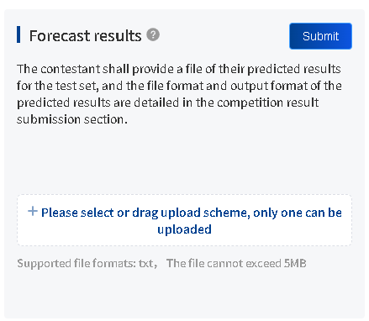

****2.Submission of Code and Model Parameters****

* At the bottom left corner of the preliminary contest page, download the "Upload Tools". Versions are available for both Windows and Mac, with the Windows version being recommended.
* Code and model parameters must be uploaded using the downloaded "Upload Tools". Ignore any error messages from antivirus software and add the file to the whitelist.
* Unzip the compressed package before use. If it still fails to launch, right-click and run as administrator.
* Upon successful upload, the address information will be automatically saved and displayed on the webpage backend. Refresh the page to view the address if it is not immediately visible.

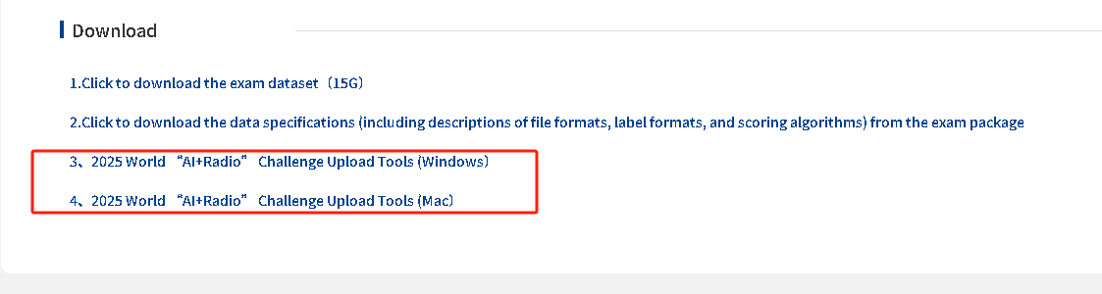

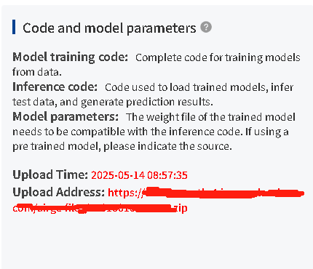

****3.Other Document Upload****

* Simply click the "Please select or drag upload scheme" button to upload the relevant documents.
* Document uploads are limited two times per day.

